Caraan, Fate Hilaryjoy R. BSIT 2F3
Exercise 4
1. List the first and last names of all employees who draw less than or equal to 95000 and are programmers, Senior programmers or Multimedia programmers.
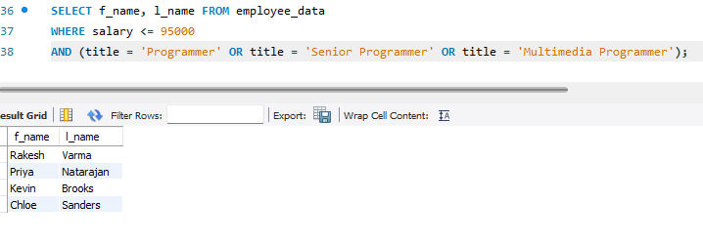
2. What is displayed by the following statement?
SELECT f_name, l_name FROM employee_data WHERE title NOT LIKE '%Marketing%' AND age < 30;
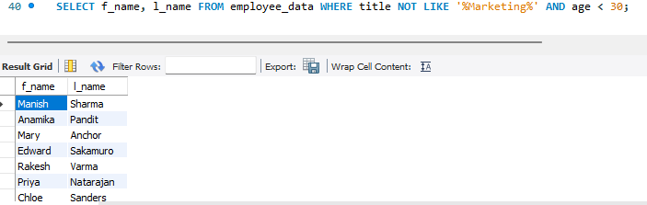

3. List all ids and names of all employees between 32 and 40 years of age.
SELECT emp_id, f_name, l_name FROM employee_data WHERE age BETWEEN 32 AND 40;
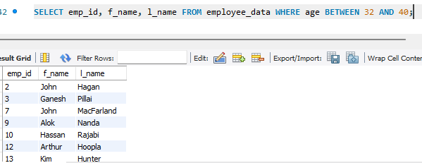
4. Select names of all employees who are 32 years of age and are not programmers.
SELECT f_name, l_name FROM employee_data
WHERE age = 32 AND title NOT LIKE '%Programmer%';
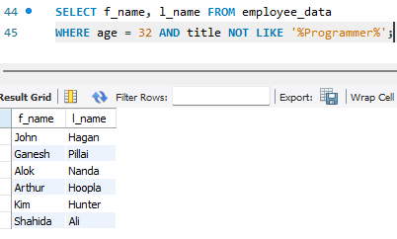

Exercise 5
1. List all employees who hold the titles of "Senior Programmer" and "Multimedia Programmer".
SELECT f_name, l_name FROM employee_data WHERE title IN ('Senior Programmer', 'Multimedia Programmer');
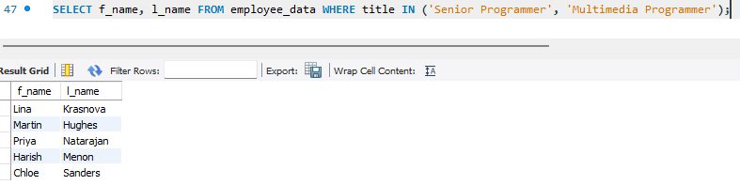

2. List all employee names with salaries for employees who draw between $70,000 and $90,000.
SELECT f_name, l_name, salary FROM employee_data WHERE salary BETWEEN 70000 AND 90000;
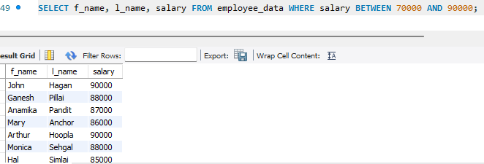
3. What will the following statement display?
SELECT f_name, l_name, title FROM employee_data WHERE title NOT IN ('Programmer', 'Senior Programmer', 'Multimedia Programmer');
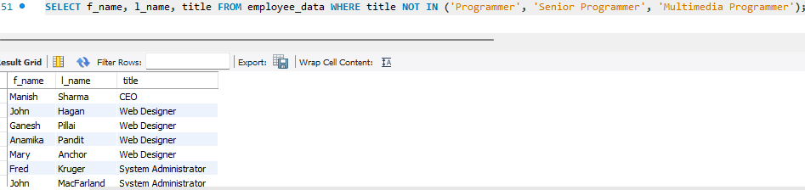
4. Here is a more complex statement that combines both BETWEEN and IN. What will it display?
SELECT f_name, l_name, title, age
FROM employee_data
WHERE title NOT IN ('Programmer', 'Senior Programmer', 'Multimedia Programmer')
AND age NOT BETWEEN 28 AND 32;
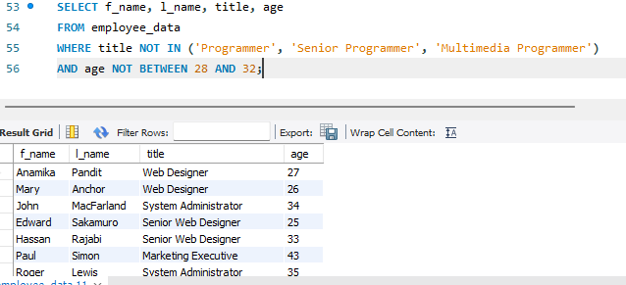

Exercise 6
1. List all employees on the basis of the salary they draw.
SELECT * FROM employee_data ORDER BY salary;
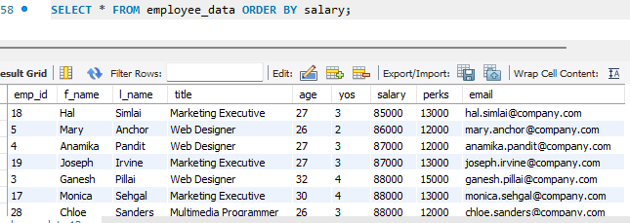

2. List all employees in descending order of their years of service.
SELECT * FROM employee_data ORDER BY yos DESC;
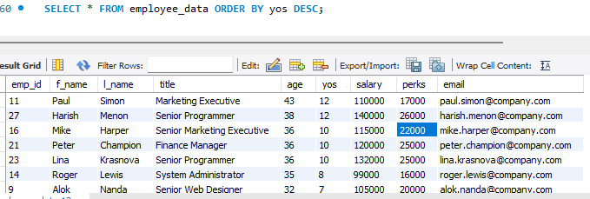
3. What does this statement display?
SELECT f_name, l_name FROM employee_data LIMIT 5;
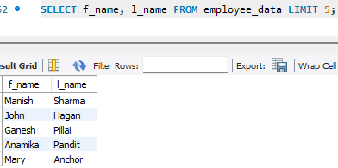
4. Display employees (last names followed by first names) who hold the title Programmer, Senior Programmer, or Web Designer and sort their last names alphabetically.
SELECT l_name, f_name FROM employee_data WHERE title IN ('Programmer', 'Senior Programmer', 'Web Designer') ORDER BY l_name;
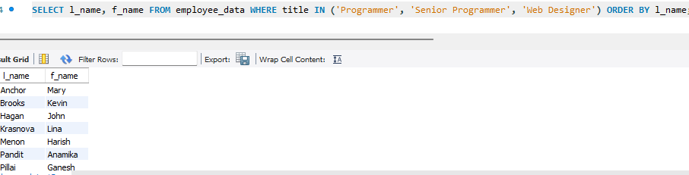

Exercise 7
1. List the names of 5 youngest employees in the company.
SELECT f_name, l_name FROM employee_data ORDER BY age ASC LIMIT 5;
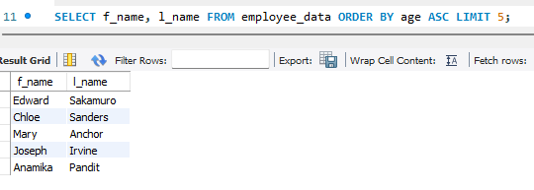
2. Extract the next 5 entries starting with the 10th row.
SELECT f_name, l_name FROM employee_data LIMIT 9,5;
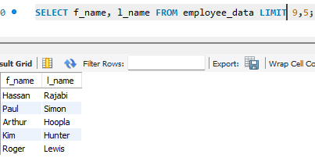
3. Display the names and salary of the employee who draws the largest salary.
SELECT f_name, l_name, salary FROM employee_data ORDER BY salary DESC LIMIT 1;
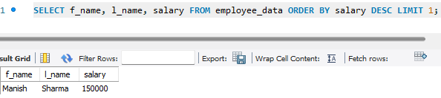

4. What does the following statement display?
SELECT emp_id, age, perks FROM employee_data ORDER BY perks DESC LIMIT 10;
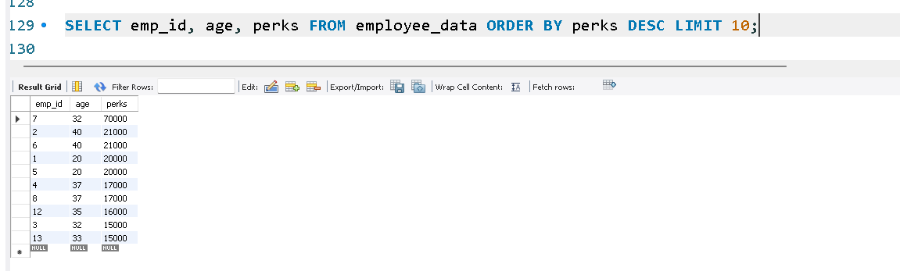

Exercise 8
1. How many unique salary packages does our company Bignet offer?
SELECT COUNT(DISTINCT salary) FROM employee_data;
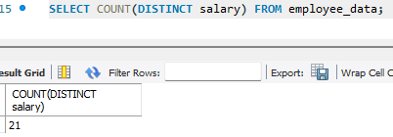

2. List the average age of employees working at Bignet.
SELECT AVG(age) FROM employee_data;
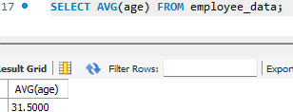
3. How many distinct first names do we have in our database?
SELECT COUNT(DISTINCT f_name) FROM employee_data;
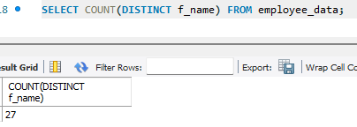

Exercise 9
1. List the minimum perks package.
SELECT MIN(perks) FROM employee_data;
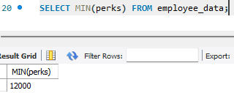
2. List the maximum salary given to a "Programmer".
SELECT MAX(salary) FROM employee_data WHERE title='Programmer';
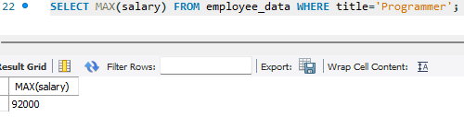
3. Display the age of the oldest “Marketing Executive”.
SELECT MAX(age) FROM employee_data WHERE title='Marketing Executive';
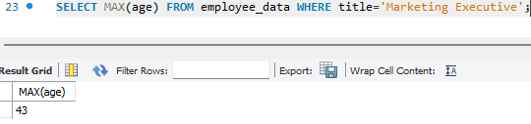

4. Find the first and last names of the oldest employee.
SELECT f_name, l_name FROM employee_data ORDER BY age DESC LIMIT 1;
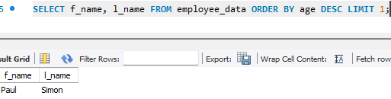
Exercise 10
1. Display the sum of ages of employees in Bignet.
SELECT SUM(age) FROM employee_data;
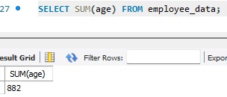
2. How would you calculate the total years of service the employees of Bignet have in the company?
SELECT SUM(yos) FROM employee_data;
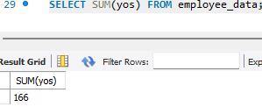
3. Calculate the sum of salaries and the average age of employees who hold CEO as their title.
SELECT SUM(salary) FROM employee_data WHERE title='CEO';
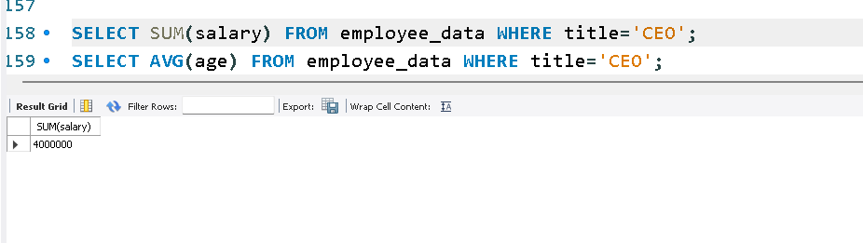
SELECT AVG(age) FROM employee_data WHERE title='CEO';
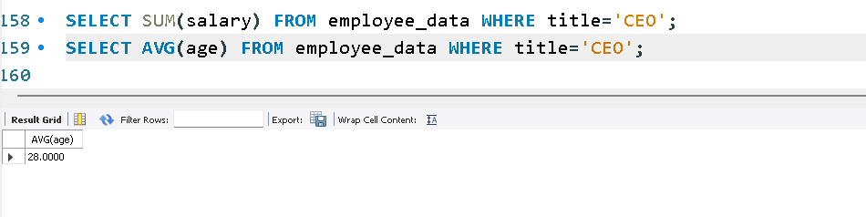

4. What do you understand from the following statement?
SELECT (SUM(perks)/SUM(salary)*100) FROM employee_data;
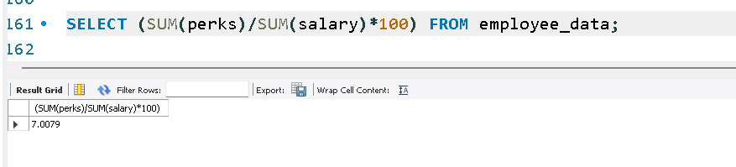
Exercise 11
1. Count the number of employees who have been with Bignet for four or more years.
SELECT COUNT(*) FROM employee_data WHERE yos >= 4;
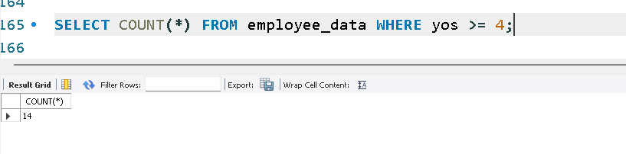
2. Count employees based on their ages.
SELECT age, COUNT(*) FROM employee_data GROUP BY age;
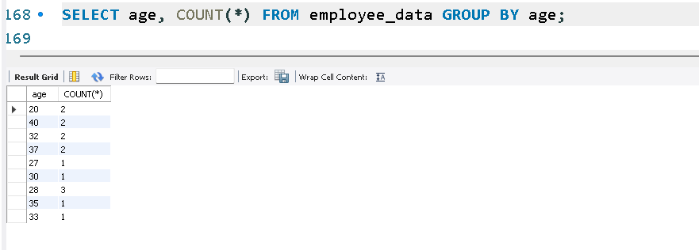

Exercise 12
1. List departments and average ages where the average age is more than 30.
SELECT title, AVG(age) AS AvgAge
FROM employee_data
GROUP BY title
HAVING AVG(age) > 30;
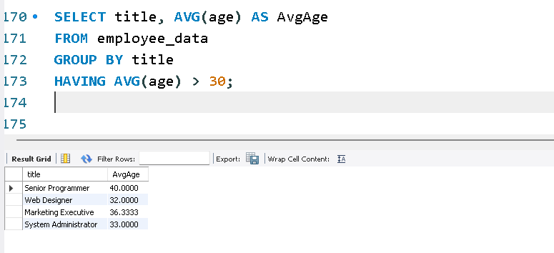

Exercise 13
1. Which command displays the MySQL version?
SELECT VERSION();
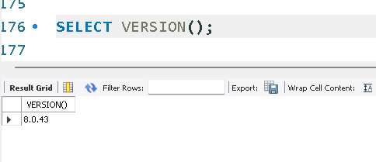

2. Use the SELECT command to evaluate 4 X 4 X 4 and name the column Cube of 4.
SELECT (4*4*4) AS `Cube of 4`;
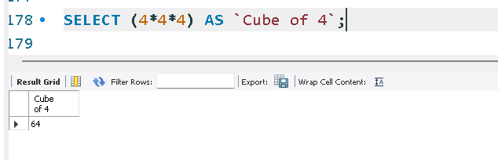

3. Display your name with SELECT.
SELECT 'Fate Hilaryjoy Caraan';
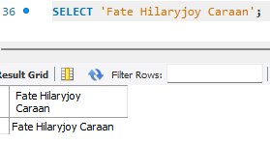

Exercise 14
- Our CEO falls in love with the petite Web Developer. ‘Anamika Pandit’. She now wants her last name to be changed to ‘Sharma’
UPDATE employee_data
SET l_name = 'Sharma'
WHERE f_name = 'Anamika' AND l_name = 'Pandit';
SELECT f_name, l_name, title FROM employee_data WHERE f_name = 'Anamika';
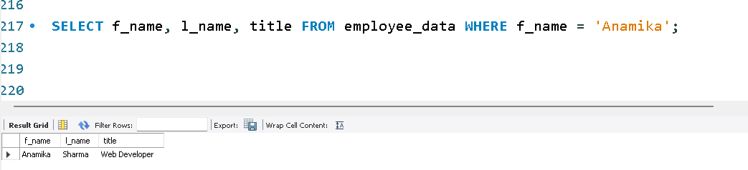

2. All multimedia programmers now want to be called Multimedia Specialist
UPDATE employee_data
SET title = 'Multimedia Specialist'
WHERE title = 'Multimedia Programmer';
SELECT f_name, l_name, title FROM employee_data WHERE title = 'Multimedia Specialist';
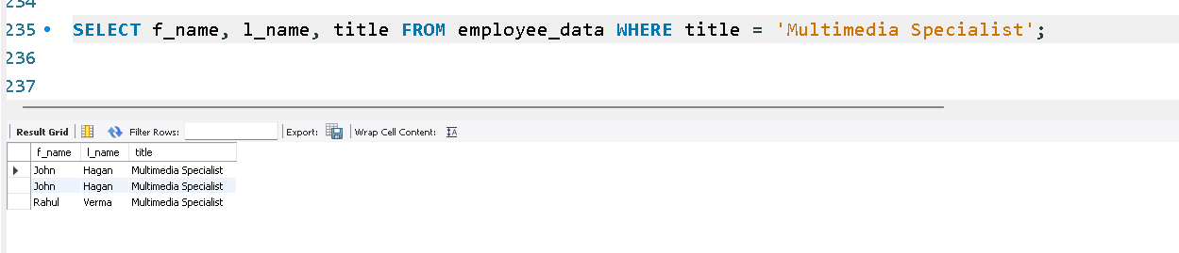

- After this marriage, the CEO gives everyone a raise. Increase the salaries of all employees (except the CEO) by $10,000.
UPDATE employee_data
SET salary = salary + 10000
WHERE title != 'CEO';
SELECT f_name, l_name, title, salary FROM employee_data;
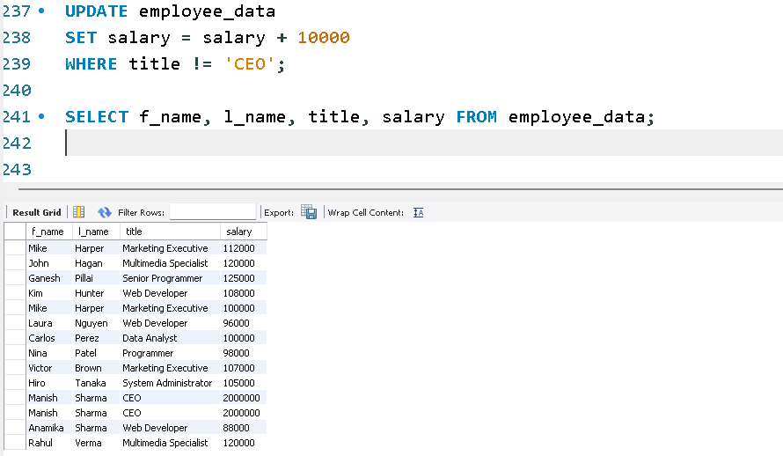
Exercise 15
1. List all employee ids and birth dates who were born before 1965.
SELECT e_id, birth_date FROM employee_per WHERE birth_date < '1965-01-01';
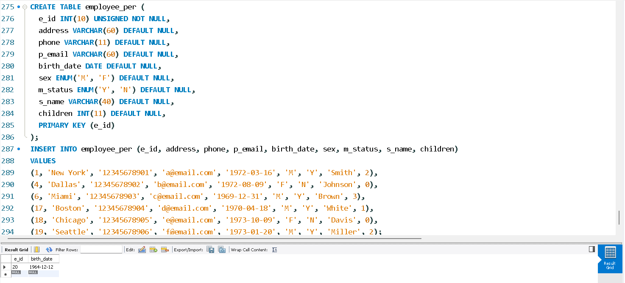
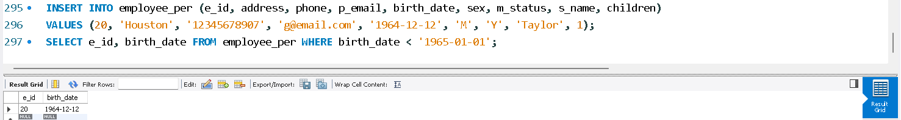

2. Display ids and birth dates of employees born in and between 1970 and 1972.
SELECT e_id, birth_date FROM employee_per WHERE birth_date >= '1970-01-01' AND birth_date <= '1972-12-31';
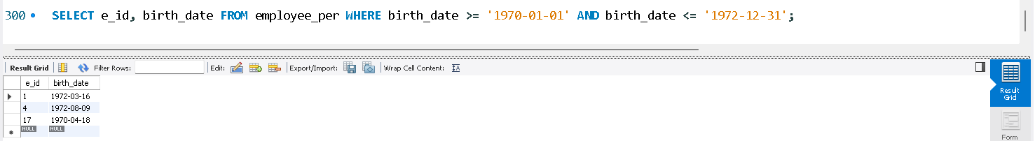

Exercise 16
1. List ids, birth dates, and emails of employees born in April.
SELECT e_id, birth_date, p_email FROM employee_per WHERE MONTH(birth_date) = 4;
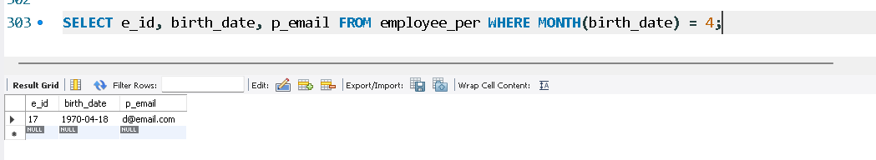
2. Display ids, birth dates, and spouse names of employees born in 1969, sorted by spouse names.
SELECT e_id, birth_date, s_name FROM employee_per WHERE YEAR(birth_date) = 1969 ORDER BY spouse_name;
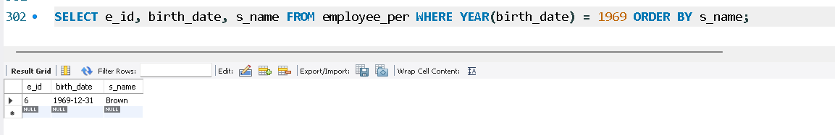

3. List the employee ids for employees born under the current month.
SELECT e_id FROM employee_per WHERE MONTH(birth_date) = MONTH(CURRENT_DATE);
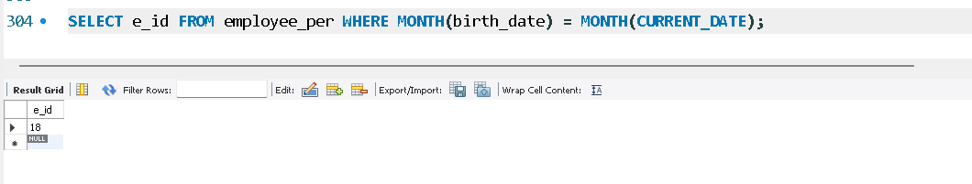

4. How many unique birth years do we have?
SELECT COUNT(DISTINCT YEAR(birth_date)) FROM employee_per;
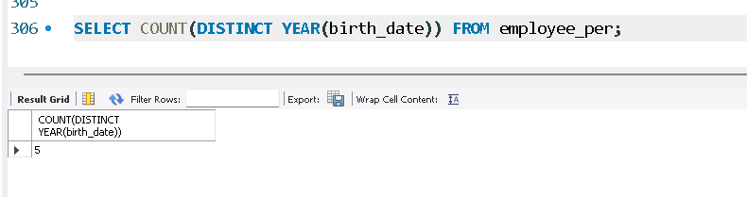

5. Display a list of unique birth years and the number of employees born under each.
SELECT YEAR(birth_date) AS birth_year, COUNT(*) AS emp_count FROM employee_per GROUP BY birth_year;
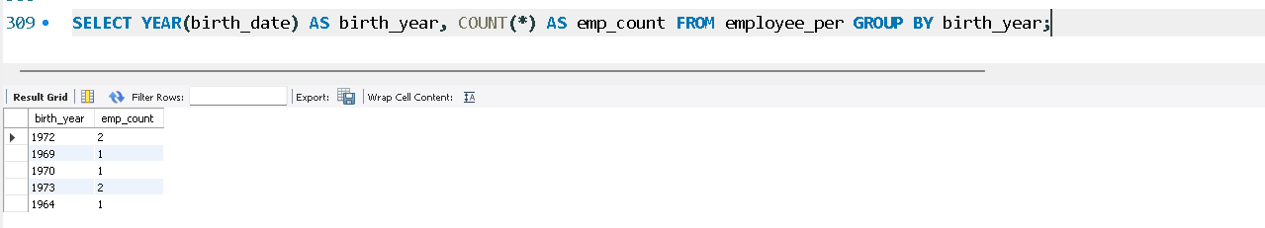

6. How many employees were born under each month? Display should have month names (not numbers) and sorted with the month having the largest number listed first.
SELECT MONTHNAME(birth_date) AS month_name, COUNT(*) AS emp_count
FROM employee_per
GROUP BY month_name
ORDER BY emp_count DESC;
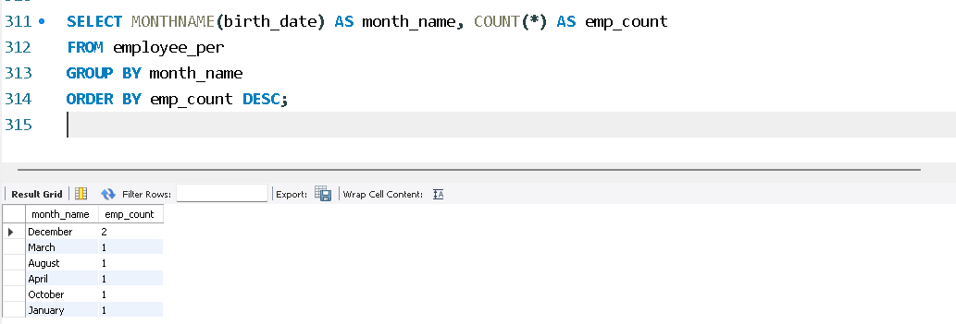

Exercise 17
1. Find and list the ids and spouse names of all employees who are married.
SELECT e_id, s_name FROM employee_per WHERE m_status = 'M';
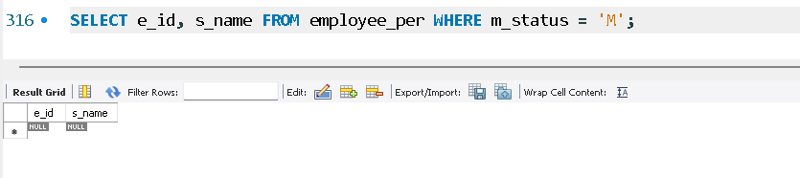

2. Change the above so that the display is sorted on spouse names.
SELECT e_id, s_name FROM employee_per WHERE m_status = 'M' ORDER BY s_name;
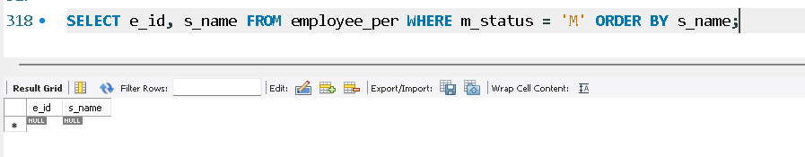

3. How many employees are there?
SELECT COUNT(*) FROM employee_per;
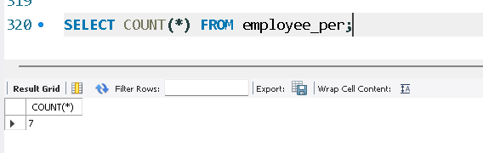

4. How many of your employees are married and unmarried (female)?
SELECT m_status, COUNT(*) FROM employee_per WHERE sex = 'F' GROUP BY m_status;
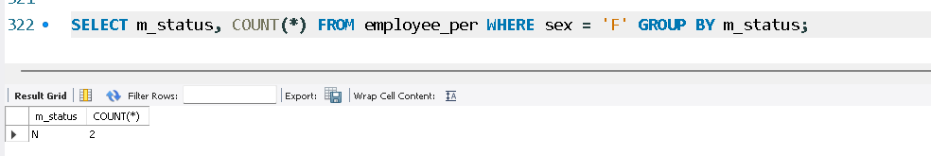

5. Make unique groups of children and find the number in each group.
SELECT children, COUNT(*) FROM employee_per GROUP BY children;
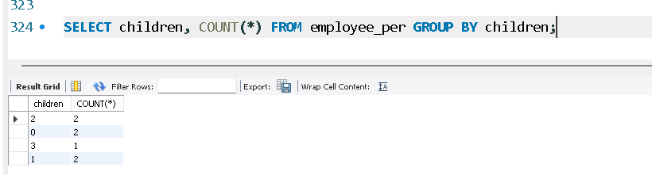
6. Sort the display with the group having maximum children at the top.
SELECT children, COUNT(*) AS num_employees
FROM employee_per
GROUP BY children
ORDER BY num_employees DESC;
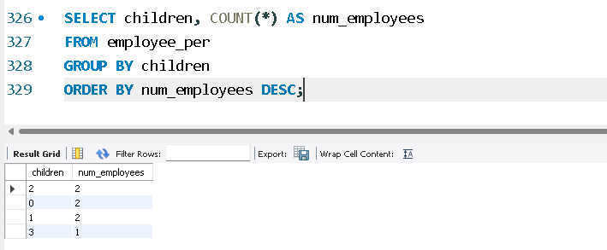
REFERENCES (INSERTS)
INSERT INTO employees (f_name, l_name, title, age, yos, salary, perks, email) VALUES
('Manish', 'Sharma', 'CEO', 28, 5, 150000, 25000, 'manish.sharma@company.com'),
('John', 'Hagan', 'Web Designer', 32, 4, 90000, 15000, 'john.hagan@company.com'),
('Ganesh', 'Pillai', 'Web Designer', 32, 4, 88000, 15000, 'ganesh.pillai@company.com'),
('Anamika', 'Pandit', 'Web Designer', 27, 3, 87000, 12000, 'anamika.pandit@company.com'),
('Mary', 'Anchor', 'Web Designer', 26, 2, 86000, 12000, 'mary.anchor@company.com'),
('Fred', 'Kruger', 'System Administrator', 31, 5, 95000, 16000, 'fred.kruger@company.com'),
('John', 'MacFarland', 'System Administrator', 34, 6, 98000, 16000, 'john.macfarland@company.com'),
('Edward', 'Sakamuro', 'Senior Web Designer', 25, 3, 102000, 18000, 'edward.sakamuro@company.com'),
('Alok', 'Nanda', 'Senior Web Designer', 32, 7, 105000, 20000, 'alok.nanda@company.com'),
('Hassan', 'Rajabi', 'Senior Web Designer', 33, 7, 108000, 20000, 'hassan.rajabi@company.com'),
('Paul', 'Simon', 'Marketing Executive', 43, 12, 110000, 17000, 'paul.simon@company.com'),
('Arthur', 'Hoopla', 'Marketing Executive', 32, 6, 90000, 15000, 'arthur.hoopla@company.com'),
('Kim', 'Hunter', 'Senior Web Designer', 32, 6, 107000, 19000, 'kim.hunter@company.com'),
('Roger', 'Lewis', 'System Administrator', 35, 8, 99000, 16000, 'roger.lewis@company.com'),
('Danny', 'Gibson', 'System Administrator', 34, 7, 97000, 16000, 'danny.gibson@company.com'),
('Mike', 'Harper', 'Senior Marketing Executive', 36, 10, 115000, 22000, 'mike.harper@company.com'),
('Monica', 'Sehgal', 'Marketing Executive', 30, 4, 88000, 13000, 'monica.sehgal@company.com'),
('Hal', 'Simlai', 'Marketing Executive', 27, 3, 85000, 13000, 'hal.simlai@company.com'),
('Joseph', 'Irvine', 'Marketing Executive', 27, 3, 87000, 13000, 'joseph.irvine@company.com'),
('Shahida', 'Ali', 'Customer Service Manager', 32, 7, 92000, 15000, 'shahida.ali@company.com'),
('Peter', 'Champion', 'Finance Manager', 36, 10, 120000, 25000, 'peter.champion@company.com');

INSERT INTO employees (f_name, l_name, title, age, yos, salary, perks, email) VALUES
('Rakesh', 'Varma', 'Programmer', 29, 4, 92000, 14000, 'rakesh.varma@company.com'),
('Aditya', 'Mehra', 'Senior Programmer', 34, 8, 125000, 22000, 'aditya.mehra@company.com'),
('Martin', 'Hughes', 'Multimedia Programmer', 31, 6, 98000, 16000, 'martin.hughes@company.com'),
('Kevin', 'Brooks', 'Programmer', 30, 5, 91000, 14500, 'kevin.brooks@company.com'),
('Harish', 'Menon', 'Senior Programmer', 38, 12, 140000, 26000, 'harish.menon@company.com'),
('Chloe', 'Sanders', 'Multimedia Programmer', 26, 3, 88000, 12000, 'chloe.sanders@company.com');

PS. OpenAI. (2025). ChatGPT (Version 5.1) [Large language model]. https://chat.openai.com/

